ONE-PAGE BUSINESS PLAN TEMPLATE
IDENTITY
We offer high-quality biking gear for families and regular people, not just gearheads.
PROBLEM WORTH SOLVING  It’s hard to buy a new bike in this town without being an “insider” cycling expert. | OUR SOLUTION  - New Bikes  - Repairs  - University Patrol  - Clothing & Accessories  - Used Bikes
TARGET MARKET  - College students  - Young families  - Trail enthusiasts  - Parents  s | THE COMPETITION  - Local bike shops  - Big-box retailers  - Online retailers
SALES CHANNELS  We sell bicycles and accessories directly to customers through our bike shop. We also sell via our online store and at special bike enthusiast events. | MARKETING ACTIVITIES  - Host social media pages and website  - Partner with Travel Northwest  - Attend outdoor enthusiast trade shows  - Grand opening w/deals
REVENUE  - New Bikes  - Repairs  - University Patrol  - Clothing | EXPENSES  - Inventory  - Payroll  - Marketing
MILESTONES
Milestone 1  1/1/23 | Milestone 2  1/1/23 | Milestone 3  1/1/23 | Milestone 4  1/1/23 | Milestone 5  1/1/23

TEAM AND KEY ROLES  - Garrett McKenzie (Founder)  - Jill Bloom (Shop manager)  - Tom McKey (Advisor) | PARTNERS AND RESOURCES  - The Great Outdoors  - Travel Northwest  - Cycle Parts “R” Us

Use LivePlan to
Create your
One-Page Business Plan

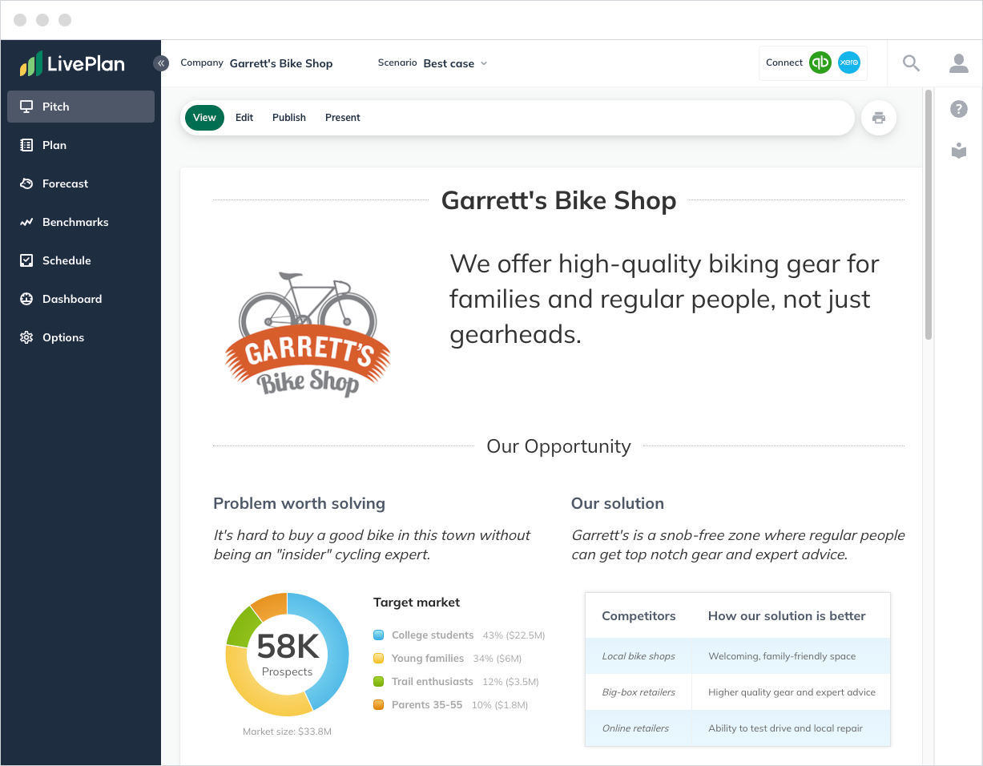

LivePlan makes it easy to collaborate online, build complete financial forecasts, and track your progress.

Learn how LivePlan can help you plan, fund, and grow your business:

www.LivePlan.com

