LEAN BUSINESS PLAN TEMPLATE – Your business plan on a single page
IDENTITY
We offer high-quality biking gear for families and regular people, not just gearheads.
PROBLEM WORTH SOLVING  It’s hard to buy a new bike in this town without being an “insider” cycling expert. | OUR SOLUTION  - New Bikes  - Repairs  - University Patrol  - Clothing & Accessories  - Used Bikes
TARGET MARKET  - College students  - Young families  - Trail enthusiasts  - Parents  s | THE COMPETITION  - Local bike shops  - Big-box retailers  - Online retailers
SALES CHANNELS  We sell bicycles and accessories directly to customers through our bike shop. We also sell via our online store and at special bike enthusiast events. | MARKETING ACTIVITIES  - Host social media pages and website  - Partner with Travel Northwest  - Attend outdoor enthusiast trade shows  - Grand opening w/deals
REVENUE  - New Bikes  - Repairs  - University Patrol  - Clothing | EXPENSES  - Inventory  - Payroll  - Marketing
MILESTONES
Milestone 1  1/1/18 | Milestone 2  1/1/18 | Milestone 3  1/1/18 | Milestone 4  1/1/18 | Milestone 5  1/1/18

TEAM AND KEY ROLES  - Garrett McKenzie (Founder)  - Jill Bloom (Shop manager)  - Tom McKey (Advisor) | PARTNERS AND RESOURCES  - The Great Outdoors  - Travel Northwest  - Cycle Parts “R” Us

Use LivePlan to
Create your
Lean Business Plan

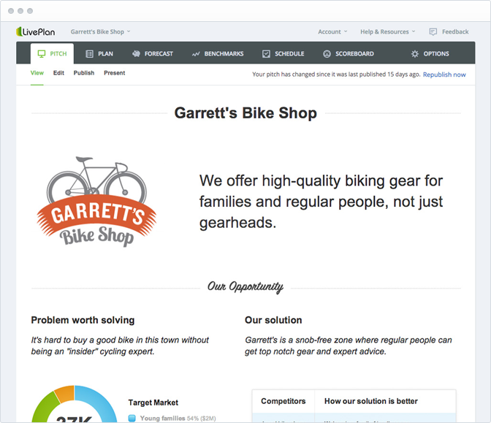

LivePlan makes it easy to collaborate online, build complete financial forecasts, and track your progress.

Learn how LivePlan can help you plan, fund, and grow your business:

www.LivePlan.com

